Financial Engineering Lab 3

Question 1

The call price for the given Initial Values is 12.123047
The put price for the given Initial Values is 5.279837
Varying S0
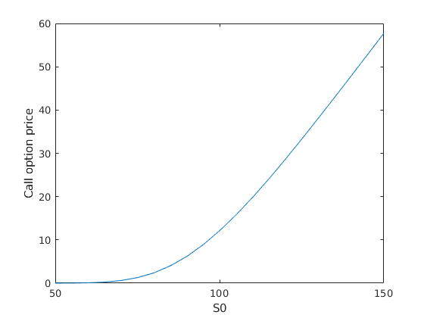
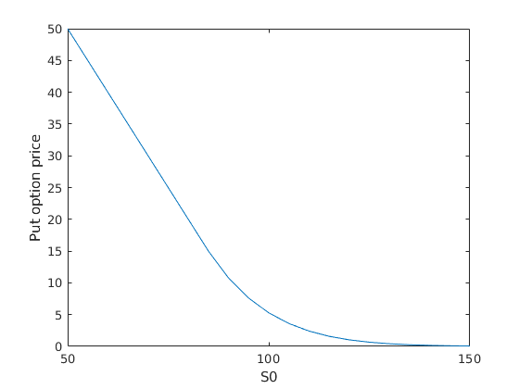
Varying K
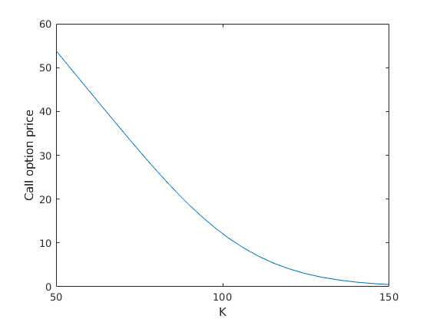
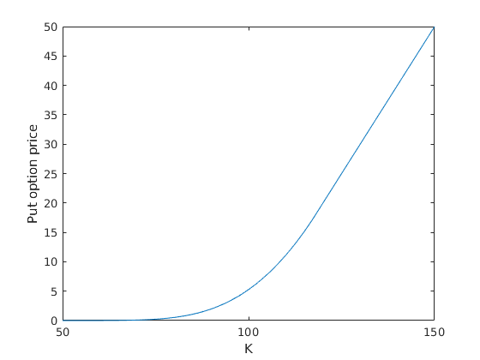
Varying r
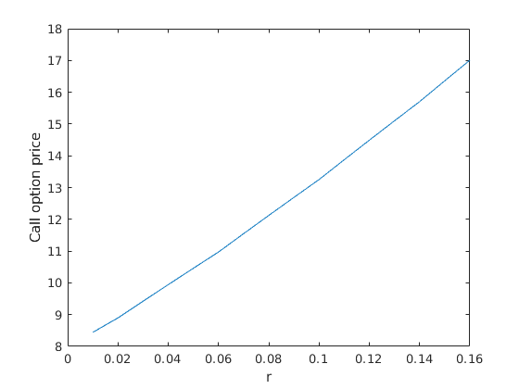
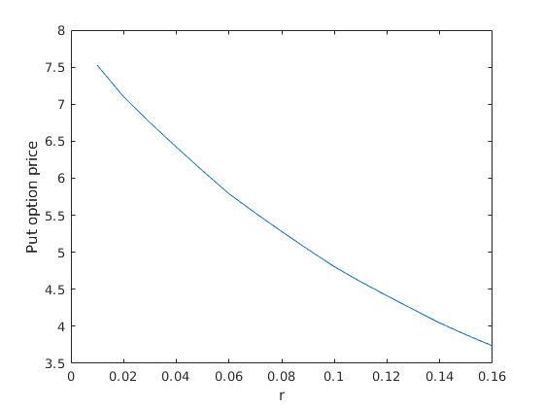
Varying sigma
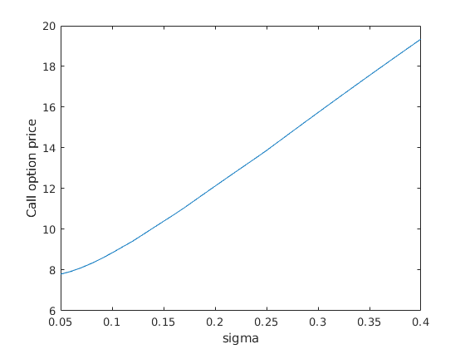
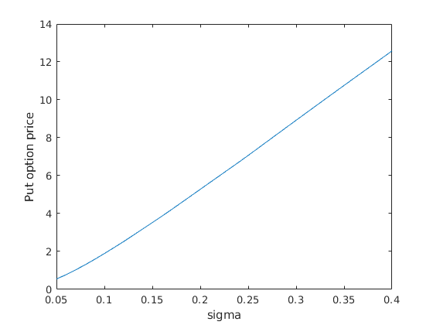
Varying M (for k=95,100,105)
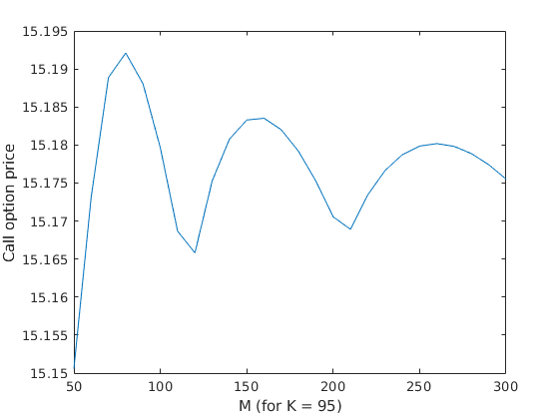
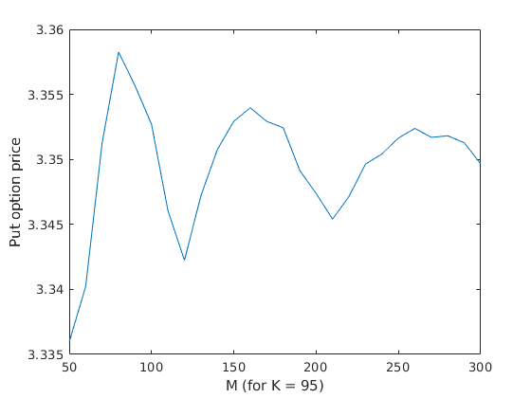
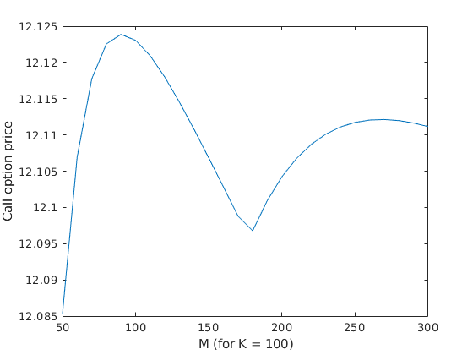
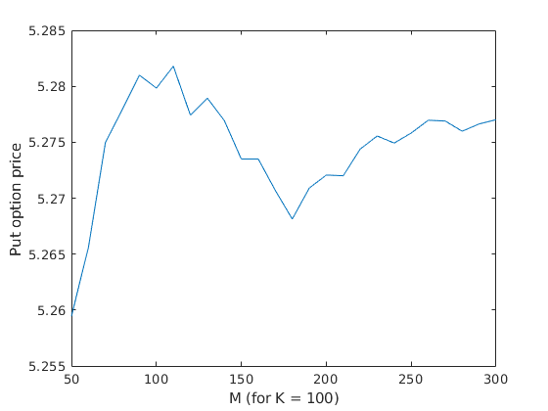
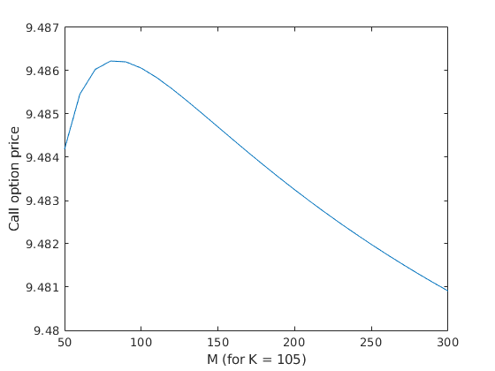
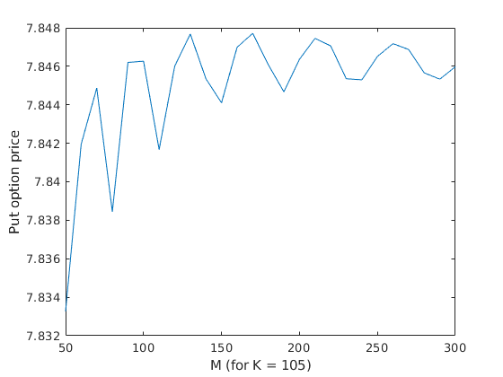

Question 2

The Basic Binomial Algorithm runs out of space and doesn’t work for M = 50.
Initial price for M = 25 is 11.003495.
Elapsed time is 27.198401 seconds.
Initial price for M = 10 is 10.080583.
Elapsed time is 0.000853 seconds.
Initial price for M = 5 is 9.119299.
Elapsed time is 0.001027 seconds.

For time step = 5, the values of the option are:
32.1054
18.8059
18.8059
2.9014
18.8059
2.9014
7.8184
0
21.2350
5.3304
7.8184
0
16.2664
0
9.3499
0
29.4826
13.5780
13.5780
0
16.2664
0
9.3499
0
25.3946
6.3745
9.3499
0
19.4527
0
11.1814
0

For time step = 4, the values of the option are:
25.0512
10.6809
10.6809
3.8469
13.0714
3.8469
8.0036
4.6005
21.1881
6.6808
8.0036
4.6005
15.6319
4.6005
9.5714
5.5016

For time step = 3, the values of the option are:
17.5821
7.1484
8.3246
6.2019
13.7129
6.2019
9.9553
7.4168

For time step = 2, the values of the option are:
12.1687
7.1479
9.7991
8.5481

For time step = 1, the values of the option are:
9.5048
9.0280

For time step = 0, the value of the option is: 9.119299

Question 3

M = 5 : 9.06572
Time taken by function: 436 microseconds
M = 10 : 10.0341
Time taken by function: 2235 microseconds
M = 25 : 10.2972
Time taken by function: 60228 microseconds
M = 50 : 10.5368
Time taken by function: 452861 microseconds

Time Taken using Basic Binomial Algorithm (Q2)
For M = 5: 0.001027 seconds
For M = 10: 0.000853 seconds
For M = 25: 27.198401 seconds
For M = 50: Ran Out of Space

Question 4

Using the computationally efficient binomial algorithm we get,

Value of M Intial European call price
1 13.714212
5 12.163186
10 12.277328
20 12.174708
50 12.085362
100 12.123047
200 12.104226
400 12.101330
Elapsed time is 0.020011 seconds for computing all the values of M, which is a considerable speed up from the basic binomial algorithm.

